FINAL PROJECT REPORT

SUBMITTED BY
RUSHIKESH EKNATH KAMBLE
COLLEGE NAME
DR. D. Y. PATIL PRATISHTHAN'S COLLEGE OF ENGINEERING, SALOKHENAGAR, KOLHAPUR

BRANCH
COMPUTER SCIENCE AND ENGINEERING (DATA SCIENCE)

ROLL ID
B.TECH 24

PROJECT NAME

Global AI Adoption in Education: A Comprehensive Global Performance Intelligence Report

Final Project Report Template
- Introduction
  - Project overviews
  - Objectives
- Project Initialization and Planning Phase
  - Define Problem Statement
  - Project Proposal (Proposed Solution)
  - Initial Project Planning
- Data Collection and Pre-processing Phase
  - Data Collection Plan and Raw Data Sources Identified
  - Data Quality Report
  - Data Exploration and Pre-processing
- Data Visualization
  - Framing Business Questions
  - Developing Visualizations
- Dashboard
  - Dashboard Design File
- Report
  - Story Design File
- Performance Testing
  - Utilization of Data filters
  - No of Calculation Field
  - No of Visualization
- Conclusion/Observation
- Future Scope
- Appendix
  - Source Code(if any)
  - GitHub & Project Demo Lin

Final Project Report

1. Introduction

1.1 Project Overview
The Global AI Adoption in Education project analyzes the adoption and usage of Artificial Intelligence in the education sector. The project uses Tableau to convert the dataset into interactive visualizations and dashboards.
The analysis focuses on AI adoption across countries and regions, differences between students and teachers, rural and urban AI usage, school AI adoption, leading AI tools, average daily AI usage, and year-wise adoption trends.

1.2 Objectives
- To analyze global AI adoption in education.
- To compare AI usage between students and teachers.
- To identify countries and regions with higher and lower AI adoption.
- To compare rural and urban AI usage.
- To identify leading AI tools used in education.
- To analyze AI adoption trends over time.
- To develop an interactive Tableau dashboard.
- To present meaningful insights through Tableau Story.

2. Project Initialization and Planning Phase

2.1 Define Problem Statement
PS | I am (Customer) | I'm trying to | But | Because | Which makes me feel
PS-  1 | Education policymaker | Understand AI adoption across regions | It is difficult to  compare adoption levels | AI adoption varies between countries and regions | Uncertain about where support is needed
PS-  2 | School administrator | Understand AI adoption in education | Student, teacher, and school usage can differ | AI adoption varies across educational environments | Unsure whether AI adoption is effective
PS-  3 | Education decision-maker | Identify rural and urban AI adoption differences | Adoption may vary by location | Technology access differs between areas | Concerned about the digital adoption gap

2.2 Project Proposal – Proposed Solution
Section | Details
Objective | Analyze global AI adoption in education using Tableau and identify important adoption patterns and trends.
Scope | Country-wise, region-wise, student, teacher, school, rural/urban, AI tool, daily usage, and year-wise analysis.
Problem  Statement | Education stakeholders need an easy way to understand and compare AI adoption across countries, regions, schools, students, and teachers.
Impact | The analysis can help identify adoption gaps and provide insights for education planning and AI implementation.
Section | Details
Approach | Collect, clean, prepare, analyze, and visualize the dataset using Tableau.
Key Features | KPI cards, bar charts, line charts, geographical map, filters, comparisons, interactive dashboard, and Tableau Story.

2.3 Initial Project Planning
Sprint | Epic | User Story | Story Points | Priority | Team | Start  Date | End Date
Sprint-  1 | Data Collection  & Cleaning | USN-1 – Collect, understand and clean the AI education dataset. | 3 | High | Self | 17Aug2026 | 18Aug2026
Sprint-  1 | Tableau Data  Preparation | USN-2 – Prepare and connect the dataset to Tableau. | 2 | High | Self | 18Aug2026 | 19Aug2026
Sprint-  2 | AI Adoption  Analysis | USN-3 – Analyze AI adoption across countries and regions. | 3 | High | Self | 19Aug2026 | 20Aug2026
Sprint-  2 | Student &  Teacher Analysis | USN-4 – Compare student and teacher AI usage. | 3 | High | Self | 19Aug2026 | 20Aug2026
Sprint-  2 | Dashboard  Development | USN-5 – Develop an interactive Tableau dashboard. | 5 | High | Self | 20Aug2026 | 21Aug2026
Sprint-  2 | Testing &  Reporting | USN-6 – Test the dashboard and prepare insights. | 3 | High | Self | 21Aug2026 | 22Aug2026

3. Data Collection and Pre-processing Phase

3.1 Data Collection Plan and Raw Data Sources Identified
Section | Details
Project Overview | Analyze global AI adoption and usage patterns in education.
Data Collection  Plan | Use the project-provided Global AI Adoption in Education dataset and prepare it for Tableau.
Raw Data Source | Global AI Adoption in Education Dataset
Format | CSV
Access | Project-provided / Public dataset

Raw Data Source Screenshot
Raw Dataset
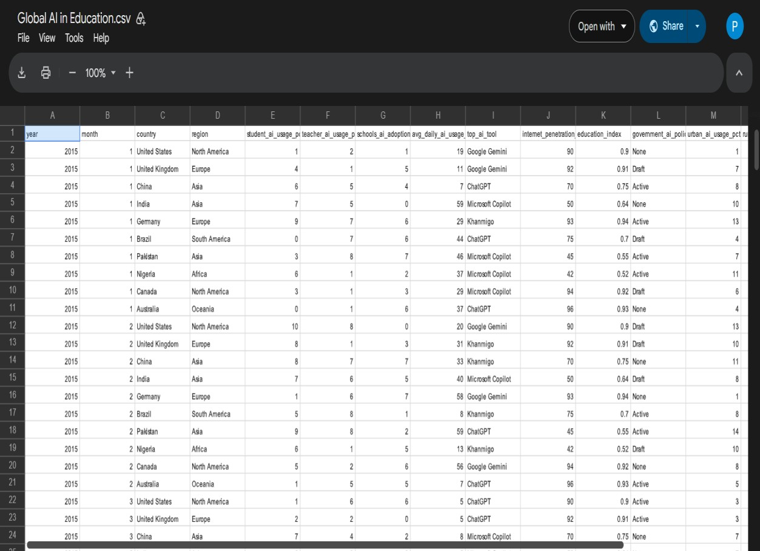

3.2 Data Quality Report
Data Source | Data Quality Issue | Severity | Resolution Plan
Global AI Adoption  Dataset | Missing or blank values | Moderate | Identify and appropriately handle missing values.
Global AI Adoption  Dataset | Duplicate records | Moderate | Check and remove duplicate records.
Global AI Adoption  Dataset | Inconsistent category names | Moderate | Standardize text and category values.
Global AI Adoption  Dataset | Incorrect data types | Low | Convert fields to appropriate Tableau data types.
Global AI Adoption  Dataset | Unnecessary fields | Low | Remove or exclude fields not required for analysis.
Global AI Adoption  Dataset | Unusual values | Moderate | Check and validate unusual values before analysis.

Raw Data Source

Attribute | Description
Dataset Name | Global AI in Education
File Format | CSV
Number of Records | 1,360
Number of Attributes | 16
Time Period | 2015–2026
Analysis Tool | Tableau

Dataset Attributes
The dataset includes the following fields:
- Year
- Month
- Country
- Region
- Student AI Usage (%)
- Teacher AI Usage (%)
- Schools AI Adoption (%)
- Average Daily AI Usage (Minutes)
- Top AI Tool
- Internet Penetration (%)
- Education Index
- Government AI Policy
- Urban AI Usage (%)
- Rural AI Usage (%)
- AI in Curriculum
- Gender Gap in AI Usage (%)

Data Quality Screenshot
Data Cleaning / Data Quality

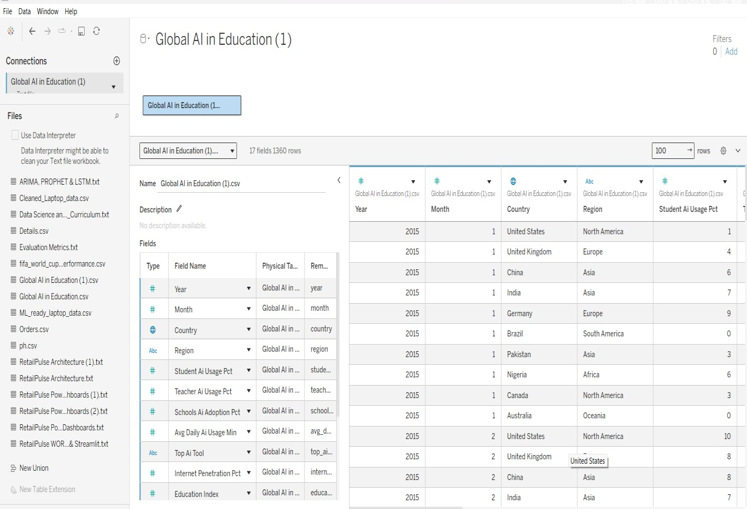

3.3 Data Exploration and Pre-processing
Section | Description
Data Overview | Dataset contains information about AI adoption in education, including student, teacher, school, regional, country, AI tool, rural/urban, and usage indicators.
Data Cleaning | Missing values, duplicates, inconsistent values, and unnecessary fields were checked.
Data Transformation | Data was filtered, sorted, and prepared for Tableau analysis.
Data Type  Conversion | Numerical, text, percentage, and date fields were assigned appropriate data types.
Column  Splitting/Merging | Fields were reviewed and organized where required.
Data Modeling | Dimensions and measures were prepared for Tableau visualizations and calculated fields.
Save Processed Data | The processed data was connected to and saved within the Tableau workbook.

Pre-processing Screenshot



4. Data Visualization

4.1 Framing Business Questions
The following business questions were developed from the Tableau workbook:
- What is the overall level of AI adoption in education?
- How does AI usage differ between students and teachers across countries?
- Which countries have the highest average daily AI usage?
- Which AI tools are the leading tools used in education?
- How has AI usage changed in rural and urban areas over the years?
- Which regions have the highest school AI adoption?
- How have school, student, and teacher AI adoption changed over the years?
- Which countries have higher or lower AI adoption?

4.2 Developing Visualizations

Visualization 1
Business Question: What is the overall level of AI adoption in education?
Visualization: AI Adoption Levels – Bar Chart
Attributes: AI Adoption Level, AI Adoption Percentage

Screenshot:

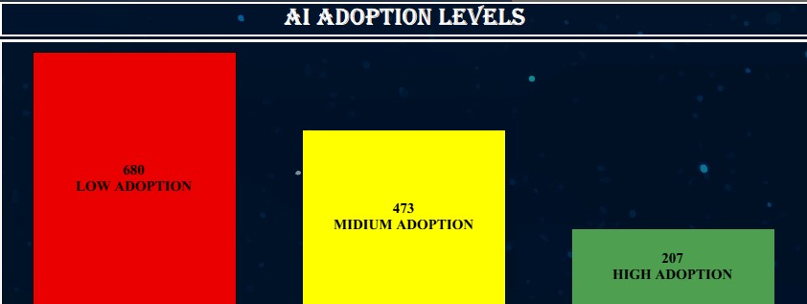

How does AI usage differ between students and teachers across
countries?
Visualization: AI Usage of Student and Teacher – Country Wise
Attributes: Country, Student AI Usage, Teacher AI Usage

Screenshot:

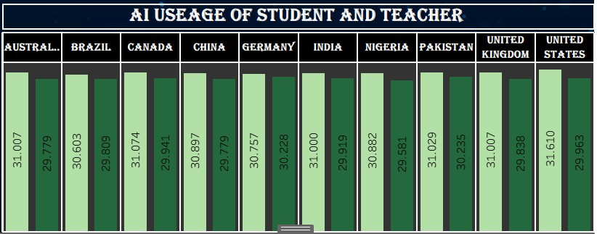

Business Question: Which countries have the highest average daily AI usage?
Visualization: Average Daily AI Usage by Country
Attributes: Country, Average Daily AI Usage Screenshot:
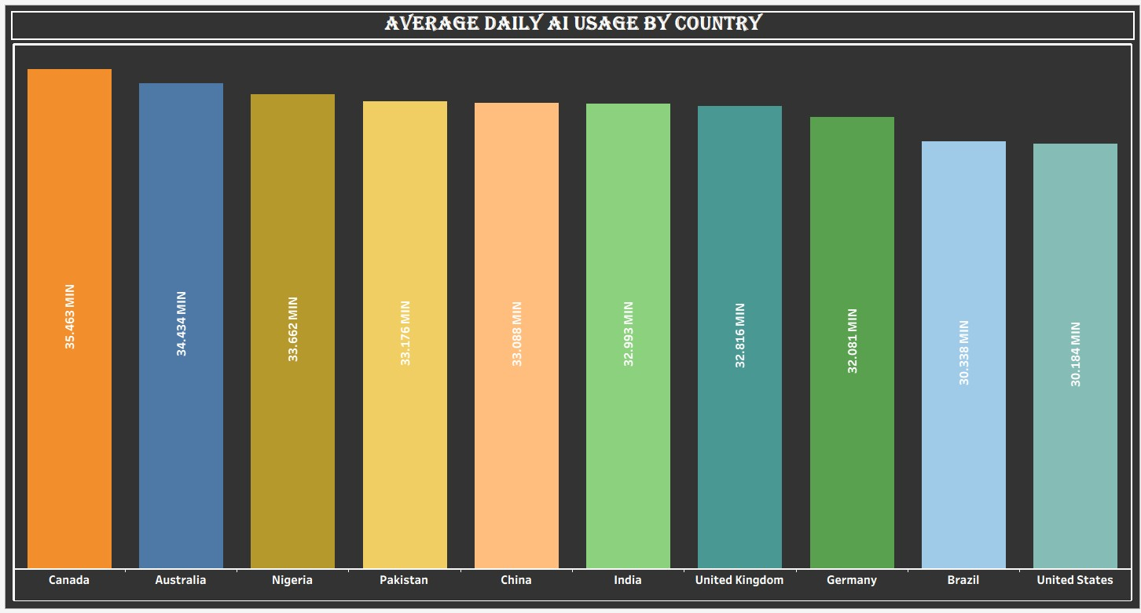

Which AI tools are the leading tools used in education?
Visualization: Comparison of Leading AI Tool
Attributes: AI Tool, Tool Usage / Adoption

Screenshot:

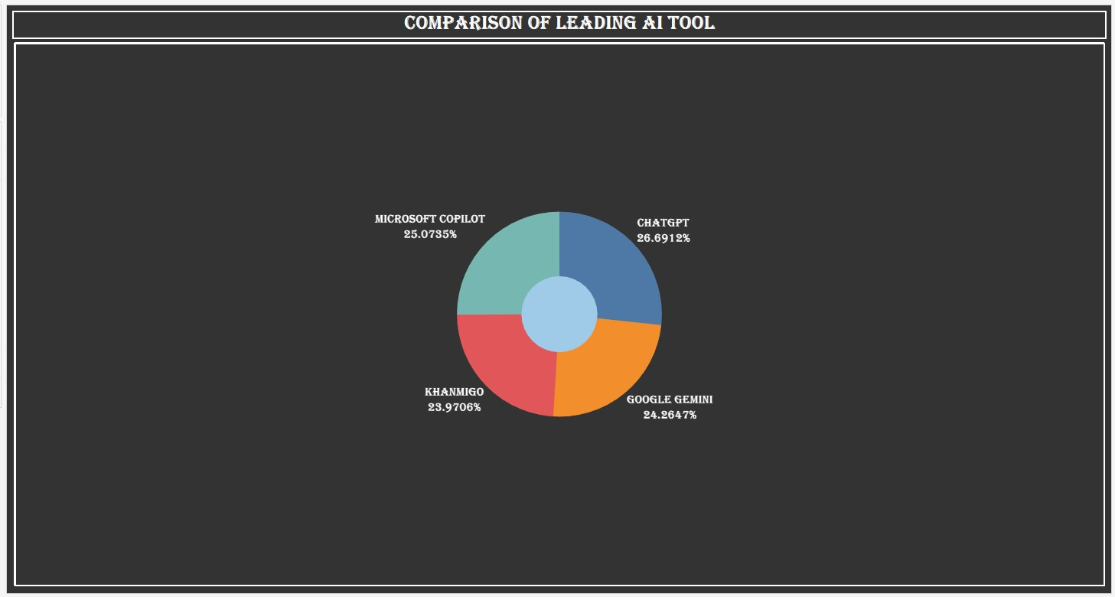

How has AI usage changed in rural and urban areas over the years?
Visualization: Growth of AI Usage in Rural and Urban Areas
Attributes: Year, Rural/Urban, AI Usage

Screenshot:

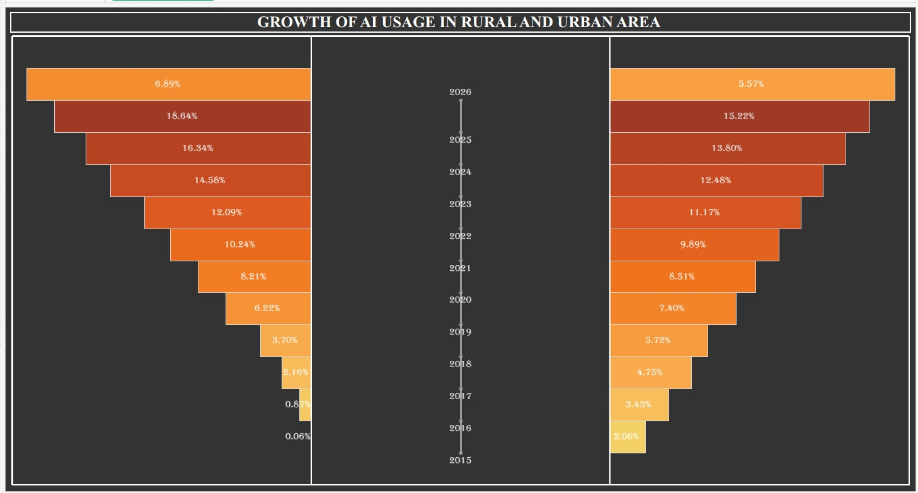

Which regions have the highest school AI adoption?
Visualization: Region Wise Schools AI Adoption
Attributes: Region, School AI Adoption Screenshot:

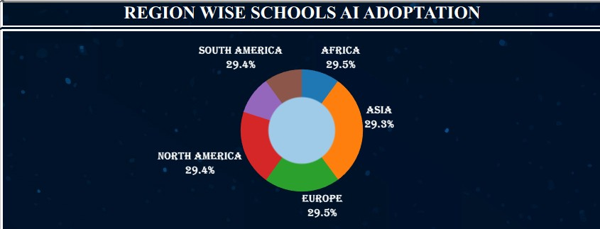

How have school, student, and teacher AI adoption changed over the
years?
Visualization: Year Wise School, Students and Teacher AI Adoption Attributes: Year, School Adoption, Student Adoption, Teacher Adoption Screenshot:

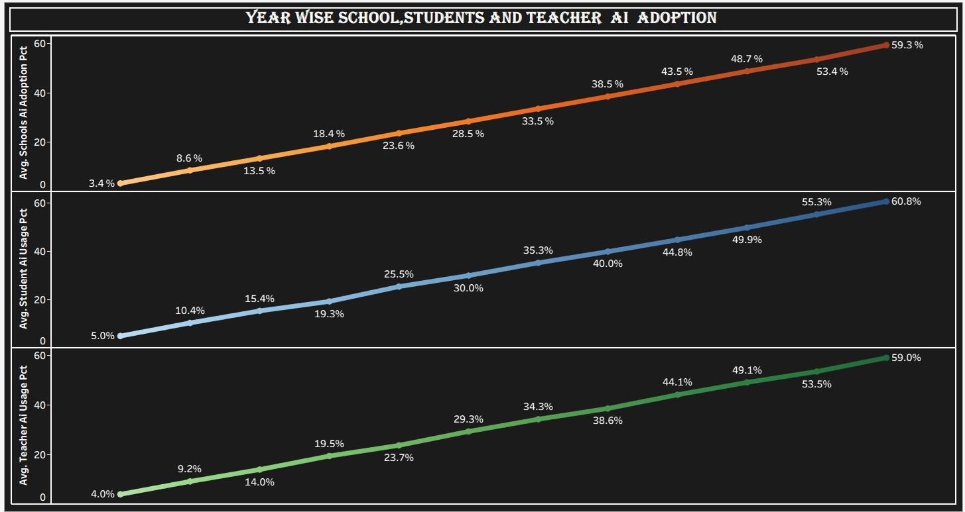

Which countries have higher or lower AI adoption?
Visualization: Global AI Adoption by Country – Map
Attributes: Country, AI Adoption Screenshot:

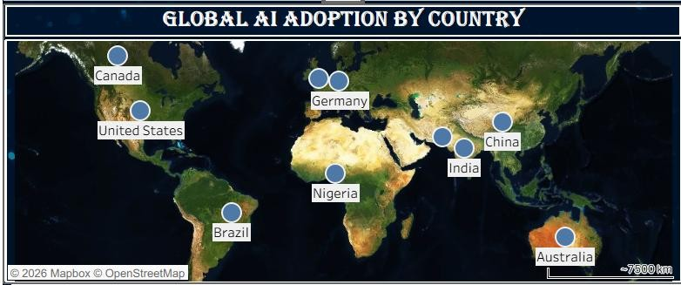

5. Dashboard

5.1 Dashboard Design File
The dashboard combines KPIs, charts, maps, filters, and comparison visualizations to provide an interactive overview of global AI adoption in education.

Dashboard Design Principles
- Clear and intuitive layout
- Appropriate visualization selection
- Consistent colour and theme
- Interactive filters
- Geographical visualization
- KPI cards
- Comparison charts
- Trend analysis
- Interactive dashboard navigation Dashboard Screenshot
MAIN TABLEAU DASHBOARD
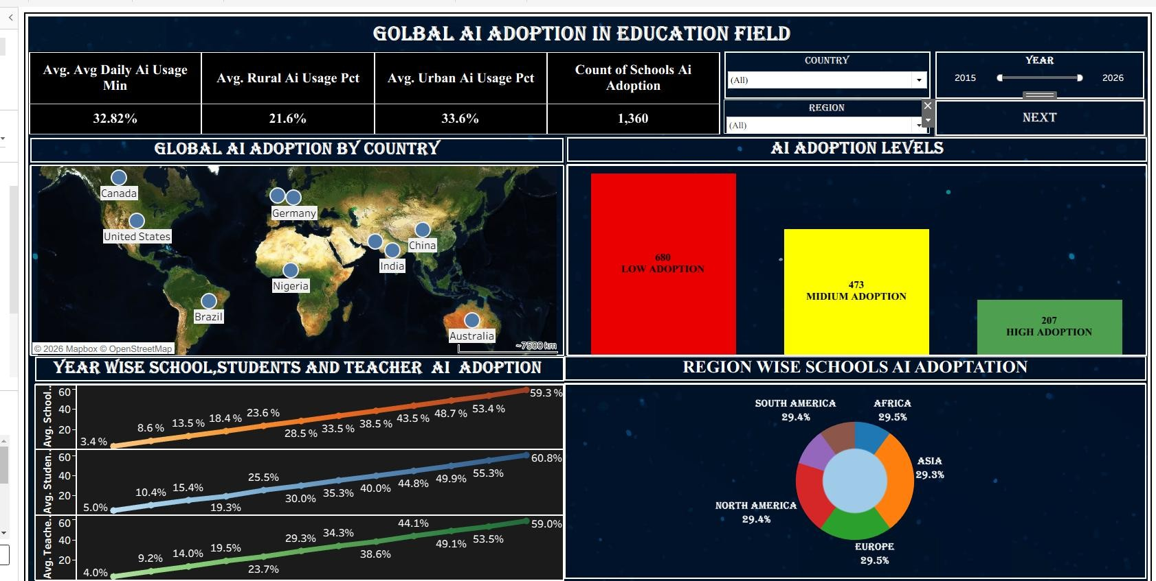

Additional Dashboard Screenshot
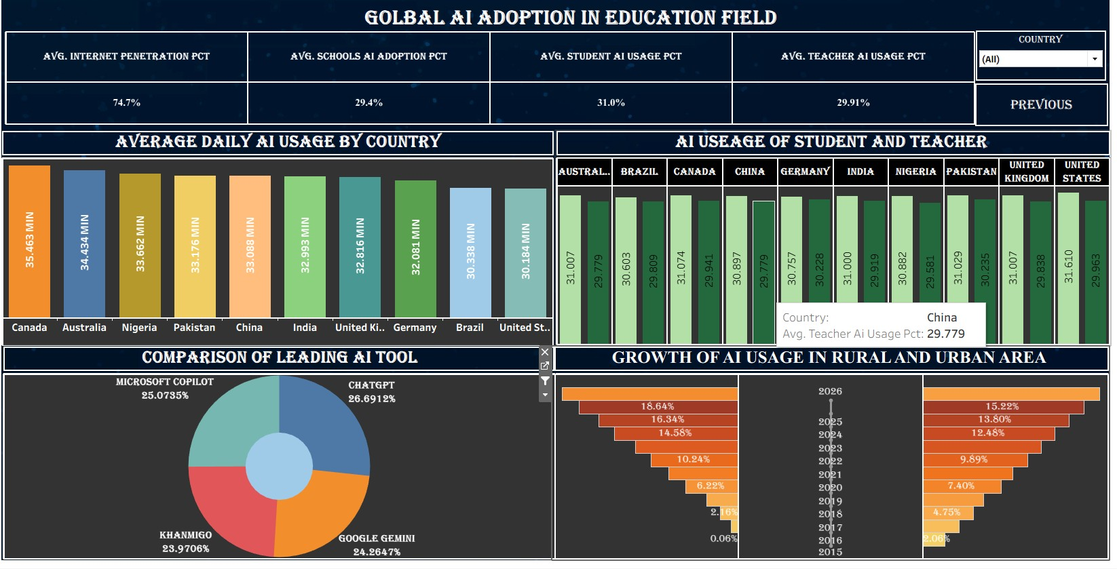

Tableau Public Dashboard Link
Link:
https://public.tableau.com/views/FINALEPROJECT1_1/Dashboard1?:language=enGB&:sid=&:redirect=auth&:display_count=n&:origin=viz_share_link

6. Report

6.1 Story Design File
The Tableau Story presents the findings in a logical sequence, beginning with overall adoption and progressing to country, regional, stakeholder, tool, and time-based analysis.

Story Flow
Story Point 1: Overall AI Adoption
↓
Story Point 2: Student & Teacher Usage
↓
Story Point 3: Average Daily AI Usage
↓
Story Point 4: Leading AI Tools
↓
Story Point 5: Rural vs. Urban Growth
↓
Story Point 6: Regional School Adoption
↓
Story Point 7: Year-wise Adoption
↓
Story Point 8: Global AI Adoption Map

Story Screenshot
Tableau Story Screenshot
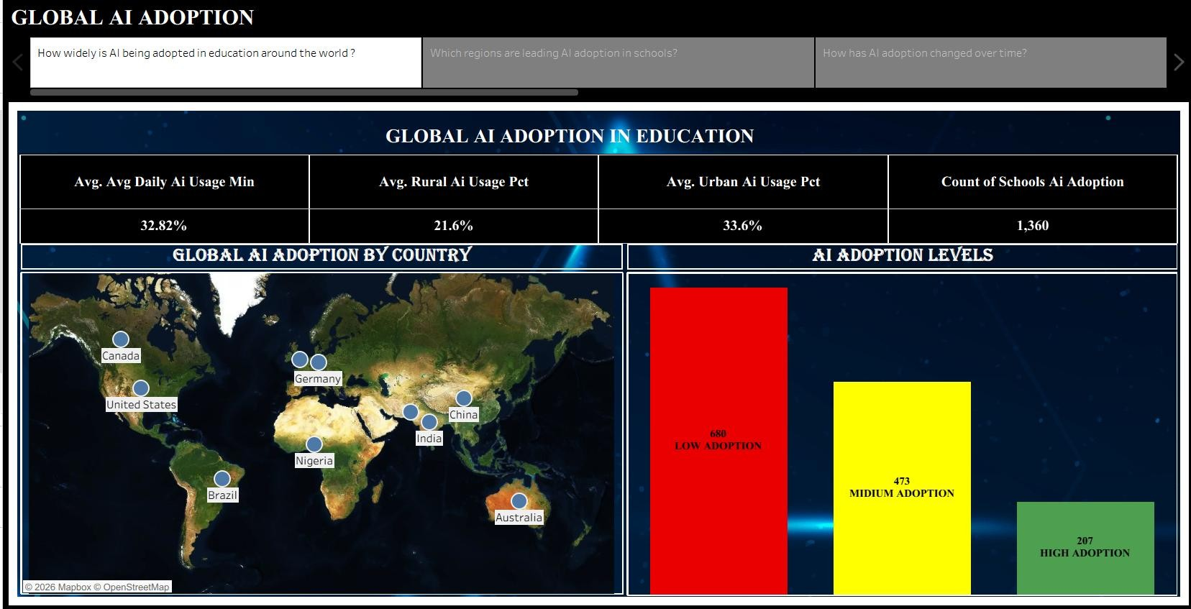

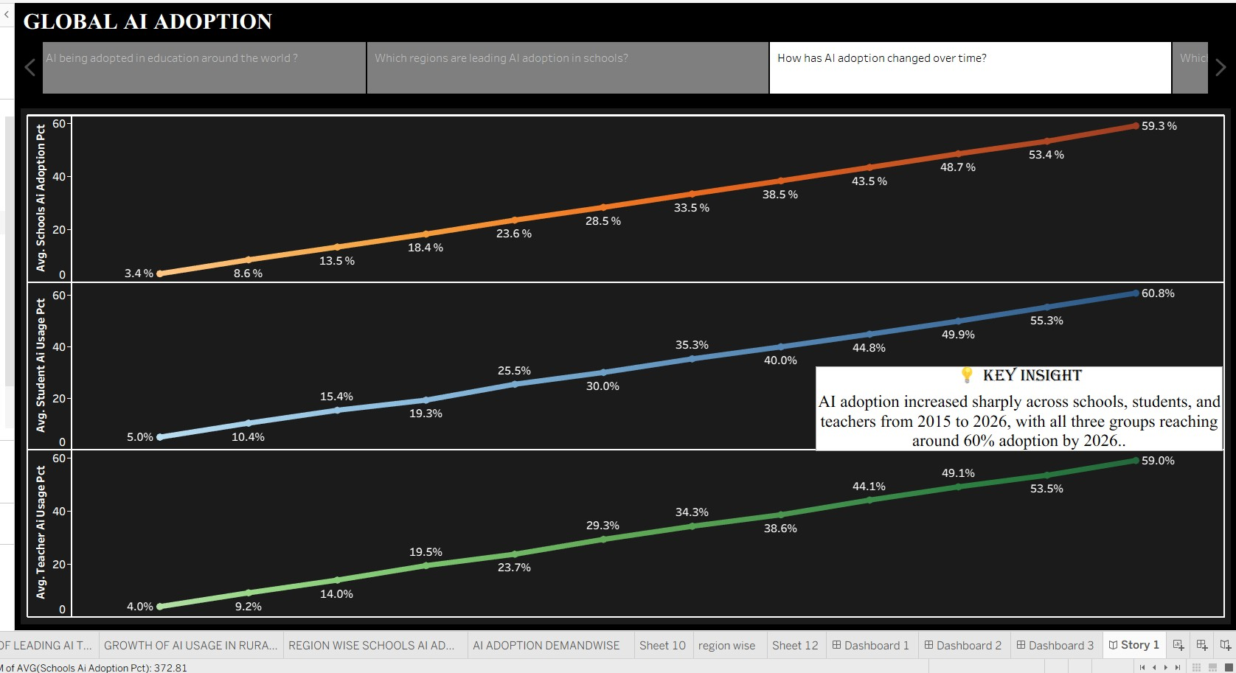
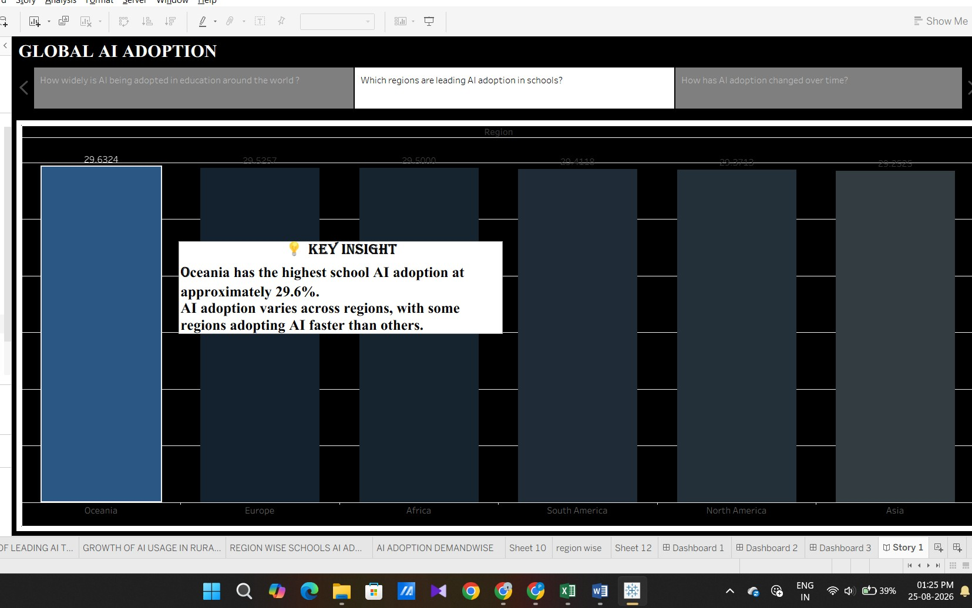

Major Story Observations
- AI adoption differs across countries and regions.
- Student and teacher AI usage can show different adoption patterns.
- Average daily AI usage varies across countries.
- Leading AI tools can be compared to understand tool adoption.
- Rural and urban AI usage shows differences in adoption.
- School AI adoption varies by region.
- School, student, and teacher adoption can be tracked over time.
- The global map provides an easy geographical comparison of AI adoption. Tableau Public Story Link
Link:
https://public.tableau.com/shared/XR6XNRZ4R?:display_count=n&:origin=viz_share_link

7. Performance Testing

7.1 Utilization of Data Filters
The Tableau dashboard uses interactive filtering to allow users to explore the data according to relevant dimensions.
Filter / Interactive Feature | Purpose
Country | Analyze individual countries
Region | Compare geographical regions
Year | Analyze trends over time
Student / Teacher | Compare stakeholder usage
Rural / Urban | Compare location-based adoption
AI Tool | Analyze leading AI tools
Screenshot Filters
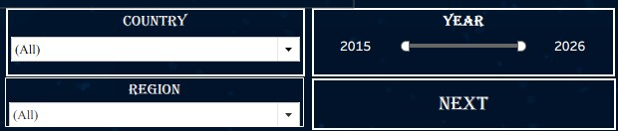

7.2 Number of Calculation Fields
Calculated fields were used where required to support AI adoption percentages, averages, comparisons, KPIs, and analytical measures.
Screenshot – Calculated Fields
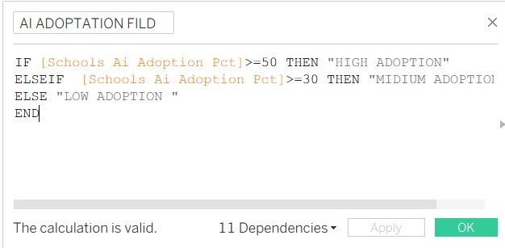
If you open Data Pane → Calculated Fields in Tableau, enter the exact number shown there.

7.3 Number of Visualizations
The project contains multiple visualizations covering:
- AI adoption levels
- Student and teacher usage
- Average daily AI usage
- Leading AI tools
- Rural and urban trends
- Regional school adoption
- Year-wise adoption
- Global country-wise adoption
Number of Visualizations: 10
Screenshot – Tableau Worksheets
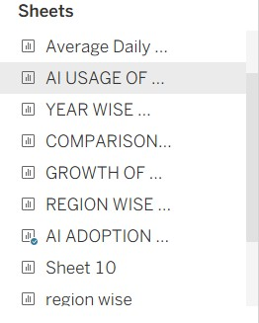

8. Conclusion / Observation
The Global AI Adoption in Education Tableau project provides an interactive analysis of AI usage across the education sector. The dashboard makes it easier to compare countries, regions, students, teachers, schools, rural and urban areas, and AI tools.
The visualizations demonstrate that AI adoption is not uniform across all educational environments. Country-wise and region-wise differences can be explored through maps and charts, while year-wise analysis helps understand adoption trends.
The project demonstrates how Tableau can transform raw education data into meaningful visual insights that support data-driven decision-making.

Key Outcomes
- Global AI adoption can be explored interactively.
- Student and teacher AI usage can be compared.
- Regional and country-wise adoption differences can be identified.
- Rural and urban adoption can be compared.
- Leading AI tools can be analyzed.
- AI adoption trends can be studied over time.
- Interactive Tableau dashboards provide decision-support insights.

9. Future Scope
- Add more recent AI adoption data.
- Include additional countries and regions.
- Add more education-related indicators.
- Introduce predictive AI adoption analysis.
- Add advanced Tableau calculations and parameters.
- Develop real-time or regularly updated dashboards.
- Add more detailed school-level analysis.
- Compare AI adoption with internet and technology accessibility.
- Publish updated versions of the dashboard on Tableau Public.

10.GitHub & Project Demo Link
GitHub Repository :
Link: [ PASTE GITHUB REPOSITORY LINK HERE ] Tableau Public Dashboard:
Link:
https://public.tableau.com/views/FINALEPROJECT1_1/Dashboard1?:language=en-
GB&:sid=&:redirect=auth&:display_count=n&:origin=viz_share_link

Tableau Public Story
Link:
https://public.tableau.com/shared/XR6XNRZ4R?:display_count=n&:origin=viz_share_link

Project Demo Video:
Link: [ PASTE PROJECT DEMO VIDEO LINK HERE ]

Final Dashboard Screenshot:
1.


2.


Final Story Screenshot :
1.
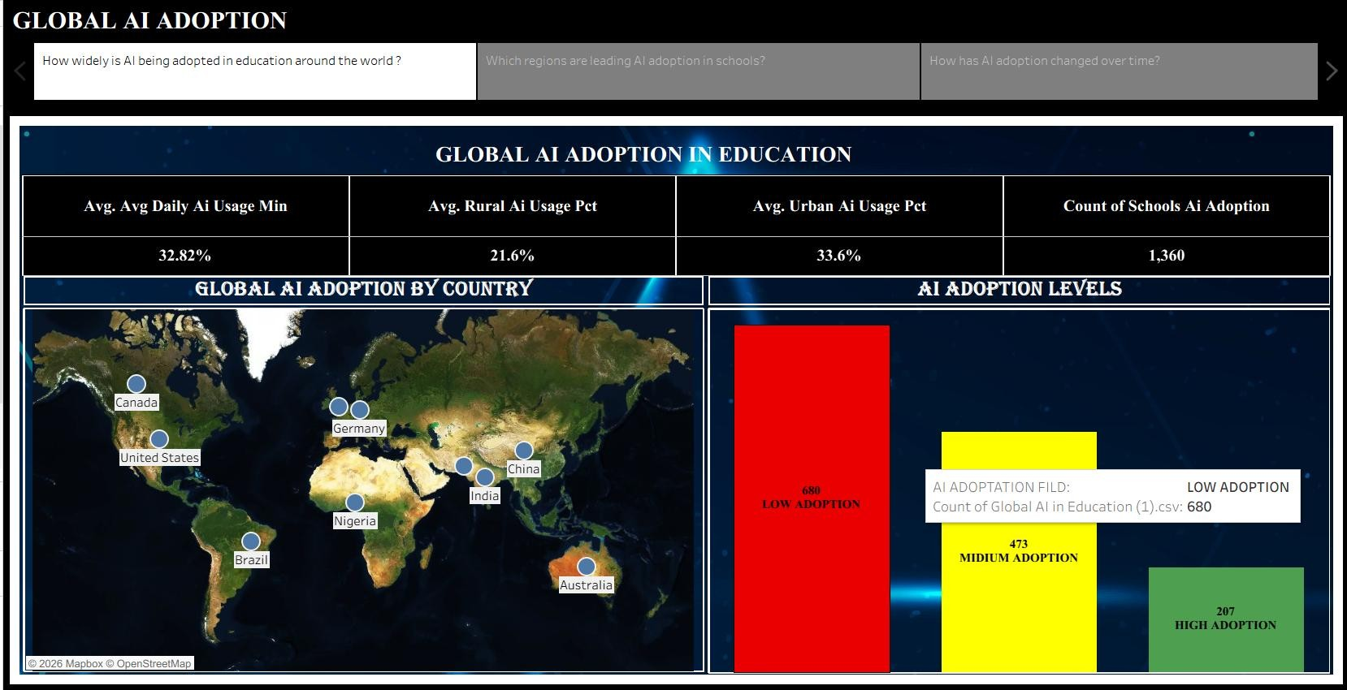
2.
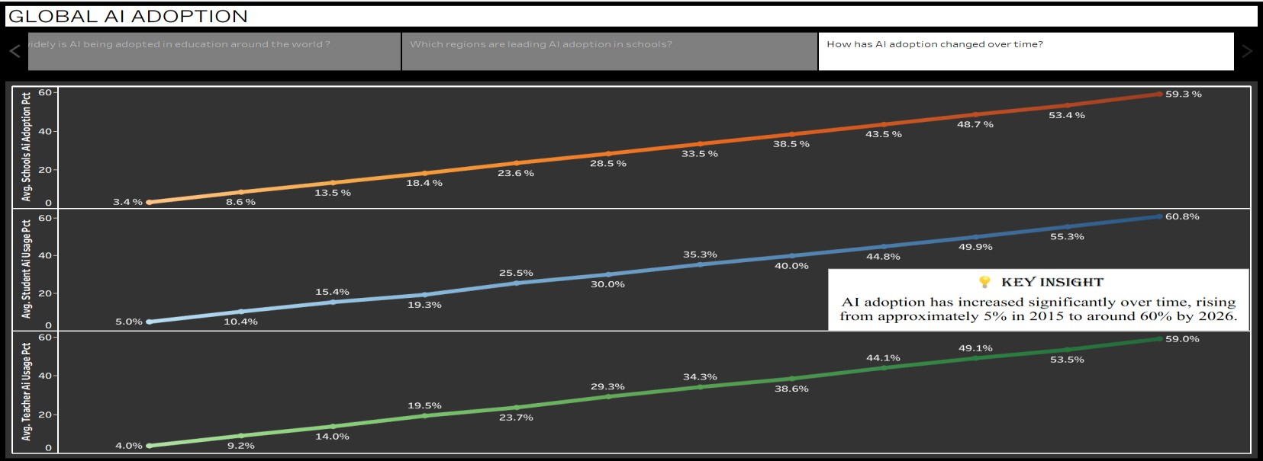
3.


